ENVIRONMENTAL POLICY

Our business statement
Home Comfort Smart Energy Solutions recognises that it has a responsibility to the environment beyond legal and regulatory requirements.
We are committed to reducing our environmental impact and continually improving our environmental performance as an integral part of our business strategy and operating methods, with regular review points.
Responsibility
Ryan Gibbons, Director is responsible for ensuring that the environmental policy is implemented. However, all employees have a responsibility in their area to ensure that the aims and objectives of the policy are met.
We take steps both internally and externally to show our commitment to reducing our environmental impact. Below is a summary of our actions:
Internally | Actions (with examples below)
Waste management | - We will reduce the amount of waste produced and recycle where possible.  - We will prevent the release of pollutants that can cause environmental damage (if relevant).  - We hold an appropriate Waste Carriers Licence WCR/R/3002718 and use SEPA approved waste management facilities for all waste disposal.
Office supplies | - We will evaluate the environmental impact of any new products we intend to purchase.  - We utilise paperless systems wherever at all possible.
Monitoring and improvement | - We will continually improve and monitor environmental performance and strive to minimise our impact on the environment at every opportunity.
Maintenance and vehicle cleaning | - The cleaning materials we use will be checked to ensure it’s as environmentally friendly as possible.  - All vehicles maintained to ensure efficient operation.
Energy | - Lights and electrical equipment will be switched off when not in use and our heating will be adjusted with energy consumption in mind.
Our people | - We will increase employee awareness through training.  - We will involve staff in the implementation of this policy, for greater commitment and improved performance.  - We will follow up with underpinning knowledge questions at coaching visits and reviews to ensure continued adherence to this policy.
Water | - We will avoid water wastage wherever possible.
Chemicals and hazardous substances | - Wherever possible we will substitute substances that are harmful to the environment with those that have less of an impact.  - Where hazardous substances have to be used, they will be handled and disposed of in the appropriate manner and in accordance with COSHH guidance.
Legal duties | - We will keep up to change with changes in environmental law and ensure we are fully compliant with our duties.

Externally | Actions (with examples below)
Transportation | - Where possible, we’ll promote the use of alternatives such as email or video/phone conferences;  - We’ll reduce the need to travel, wherever possible.  - We always seek to minimise travel and where possible share a vehicle to reduce emissions.
Customers, suppliers and other stakeholders | - We will work with suppliers, contractors and sub-contractors to improve their environmental performance.
Contractors | - We will work with contractors who are equally as committed to reducing their environmental impact and ensure when working on our behalf adhere to our policies.

Signed by:
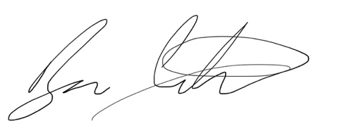
…………………………………………………………………………..
Position:
Director
…………………………………………………………………………..
Date
14/11/2022
…………………………………………………………………………..
Review date:
14/05/2023
…………………………………………………………………………..

